**Bingo Schedule for 2024-2025 Attached**

**Bingo Worker Information Sheet-Please Read**

**You have 4 Dates at the Top of your team on this Schedule for 2024-2025 School Year**

The year begins August 3rd, 2024 and ends July 26th, 2025

If you trade with someone or need help trading email Debbie Johnson at **mcabingoschedule@gmail.com**. (Do NOT email the office)

* All workers should arrive PROMPTLY at 4:30PM.
* Parents may not bring their children with them when working Bingo
* All workers are to stay until cleanup is completed and leave together.
* **All Kitchen workers are asked to bring one case of water or a 12-pack of soda (Pepsi or Coke Products).**
* **All Floor workers and Pull Tab workers are asked to bring a cake or pie. Cupcakes, Brownies and cookies don’t seem to sell with the adult crowd.**
* Even though you are assigned to a certain area, it is possible you will work in a different area where the help is needed.
* When you arrive at bingo it is your responsibility to sign the schedule. A binder with the sign-in sheets will be located in the kitchen.
* **Please do not use electronics or your cell phone when you are working. If you are not selling items on the floor, you should be watching to call back bingos.**
* We need to try and make sure no one misses their Bingo!
* We will use the School Reach Text and Voicemail System to contact everyone if bingo is cancelled for any reason such as inclement weather.
* **If for any reason you cannot work bingo for an assigned date it is your responsibility to find coverage for that evening. You may change with anyone on the Bingo list. No one outside of the Mother Catherine Parents may work Bingo.** Make the arrangements and please make sure that someone is at bingo or you will be billed $500.00. Phone numbers are provided on the schedule as well as in the family directory.
* If a parent misses working two bingos during the school year they will be removed from the bingo list and will have to pay the remaining buy-out fee.
* This is a very important fundraiser for our school. We truly appreciate your help to make it a success.

**HOW TO CALL BACK A HOLDER/PULL TAB**

**\*\*Everyone can help call back holders and bingos. To call back a bingo, read the number in the center of the winning card or bottom right number of that card (they are the same). See Image Below for how to call back a holder/pull tab.**

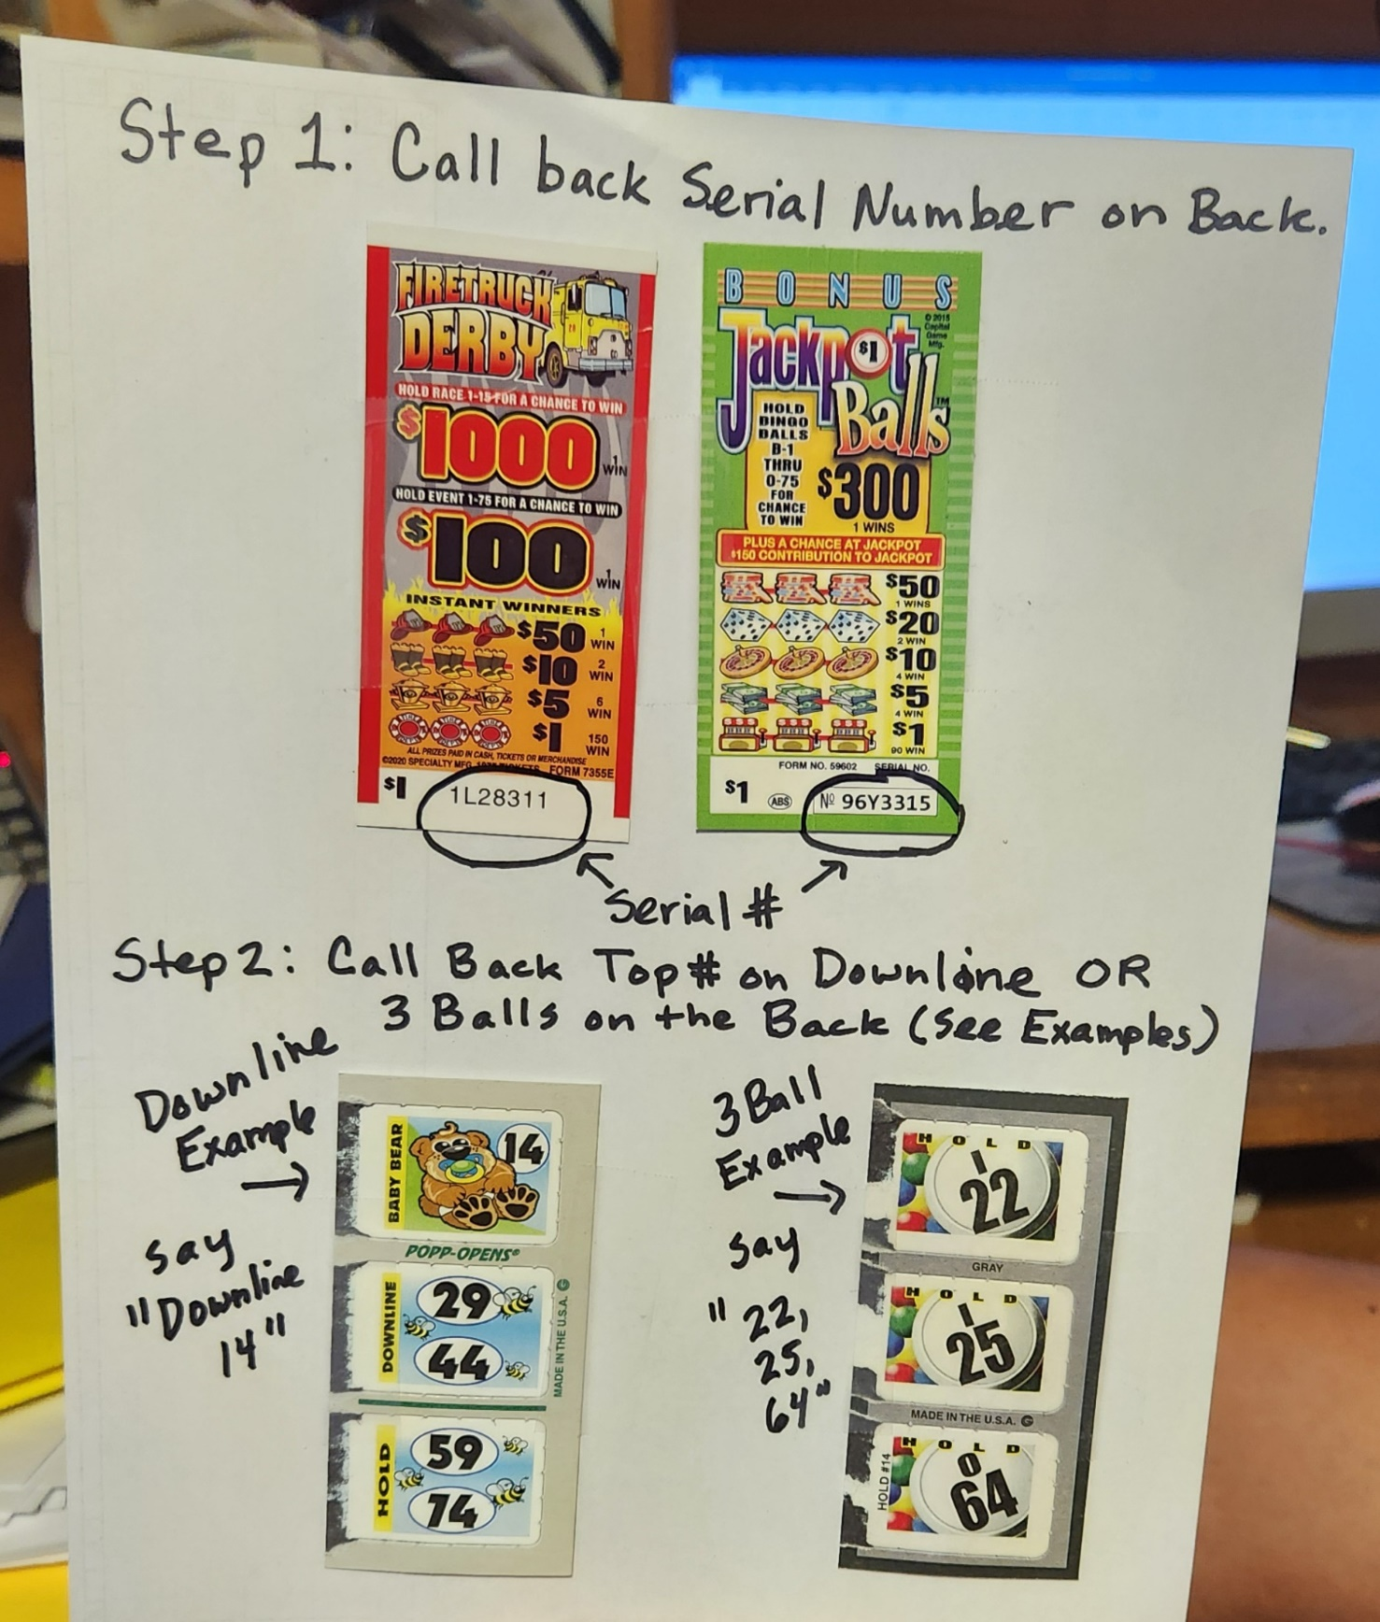

|  |  |  |  |
| --- | --- | --- | --- |
| **August 3rd October 26th February 8th May 10th** | | | |
| **Duty** | **Family Name** | **Phone Number** | **Signature** |
| Floor Worker | Widmayer |  |  |
| Floor Worker | Shaw |  |  |
| Floor Worker | Pettie |  |  |
| Pull Tabs | Winter |  |  |
| Pull Tabs | Beachy |  |  |
| Pull Tabs | Dobry |  |  |
| Kitchen | Goldsborough |  |  |
| Kitchen | Pahel |  |  |
| Kitchen | Jarboe/Gross |  |  |
| Kitchen | D’Lima |  |  |

|  |  |  |  |
| --- | --- | --- | --- |
| **August 10th November 2nd February 15th May 17th** | | | |
| **Duty** | **Family Name** | **Phone Number** | **Signature** |
| Floor Worker | Santoro |  |  |
| Floor Worker | Wright/Henry |  |  |
| Floor Worker | Hover |  |  |
| Pull Tabs | Gibson/Hall |  |  |
| Pull Tabs | McElroy/Stone |  |  |
| Pull Tabs | Postl |  |  |
| Pull Tabs | Hogan |  |  |
| Kitchen | Wright/Ethan |  |  |
| Kitchen | Frericks/Vanessa |  |  |
| Kitchen | Raley |  |  |

|  |  |  |  |
| --- | --- | --- | --- |
| **August 17th November 9th February 22nd May 24th** | | | |
| **Duty** | **Family Name** | **Phone Number** | **Signature** |
| Floor Worker | Ruefly |  |  |
| Floor Worker | Howell |  |  |
| Floor Worker | Wood/Ethan |  |  |
| Pull Tabs | Johnson/Emma |  |  |
| Pull Tabs | Stone |  |  |
| Pull Tabs | Maines |  |  |
| Pull Tabs | Gingery |  |  |
| Kitchen | Unkle |  |  |
| Kitchen | Pessagno |  |  |
| Kitchen | Tribett |  |  |

|  |  |  |  |
| --- | --- | --- | --- |
| **August 24th November 16th March 1st May 31st** | | | |
| **Duty** | **Family Name** | **Phone Number** | **Signature** |
| Floor Worker | Latham |  |  |
| Floor Worker | Coon/Brunet |  |  |
| Floor Worker | Thomas |  |  |
| Pull Tabs | Colliflower |  |  |
| Pull Tabs | Maricic |  |  |
| Pull Tabs | Hasel |  |  |
| Pull Tabs | Beverly |  |  |
| Kitchen | Curley |  |  |
| Kitchen | Navarro |  |  |
| Kitchen | Earnshaw |  |  |

|  |  |  |  |
| --- | --- | --- | --- |
| **August 31st  November 23rd March 8th June 7th** | | | |
| Duty | **Family Name** | **Phone Number** | **Signature** |
| Floor Worker | Wood |  |  |
| Floor Worker | Russell |  |  |
| Floor Worker | Hartmann/Harding |  |  |
| Pull Tabs | Groft |  |  |
| Pull Tabs | Wilkinson |  |  |
| Pull Tabs | Williams/Toby |  |  |
| Pull Tabs | Cruz |  |  |
| Kitchen | Long |  |  |
| Kitchen | Wallace/Masri |  |  |
| Kitchen | Hall/Oliver |  |  |

|  |  |  |  |
| --- | --- | --- | --- |
| **September 7th December 7th March 15th June 14th** | | | |
| **Duty** | **Family Name** | **Phone Number** | **Signature** |
| Floor Worker | Napier |  |  |
| Floor Worker | Suchter |  |  |
| Floor Worker | Burch |  |  |
| Pull Tabs | Bernd |  |  |
| Pull Tabs | Helwig |  |  |
| Pull Tabs | Nelson |  |  |
| Pull Tabs | Guy/Trevor |  |  |
| Kitchen | Bond/Pagel |  |  |
| Kitchen | Nelson/Willow |  |  |
| Kitchen | Taymen/Caden |  |  |

|  |  |  |  |
| --- | --- | --- | --- |
| **September 14th December 14th March 22nd June 21st** | | | |
| **Duty** | **Family Name** | **Phone Number** | **Signature** |
| Floor Worker | Buckler |  |  |
| Floor Worker | Richards/Jude |  |  |
| Floor Worker | Jennings |  |  |
| Pull Tabs | Kidwell |  |  |
| Pull Tabs | Ingram |  |  |
| Pull Tabs | Souder |  |  |
| Pull Tabs | Holt |  |  |
| Kitchen | Hill |  |  |
| Kitchen | King/Karley |  |  |
| Kitchen | Groht/Downing |  |  |

|  |  |  |  |
| --- | --- | --- | --- |
| **September 21st January 4th March 29th June 28th** | | | |
| **Duty** | **Family Name** | **Phone Number** | **Signature** |
| Floor Worker | Dearstine |  |  |
| Floor Worker | Watson |  |  |
| Floor Worker | Brown/Jeffrey |  |  |
| Pull Tabs | Payne |  |  |
| Pull Tabs | Sharr |  |  |
| Pull Tabs | Pritchard |  |  |
| Pull Tabs | Whitaker |  |  |
| Kitchen | Williams/Hayden |  |  |
| Kitchen | Beardon |  |  |
| Kitchen | Gill |  |  |

|  |  |  |  |
| --- | --- | --- | --- |
| **September 28th January 11th April 5th July 5th** | | | |
| **Duty** | **Family Name** | **Phone Number** | **Signature** |
| Floor Worker | Higgs |  |  |
| Floor Worker | McClanahan |  |  |
| Floor Worker | Lawrence |  |  |
| Pull Tabs | Johnson |  |  |
| Pull Tabs | Bond/Kacey |  |  |
| Pull Tabs | Groves |  |  |
| Pull Tabs | Rosa |  |  |
| Kitchen | Pinkney/Buckler |  |  |
| Kitchen | Sicheri/Kamperin |  |  |
| Kitchen | Bologna |  |  |

|  |  |  |  |
| --- | --- | --- | --- |
| **October 5th January 18th April 12th July 12th** | | | |
| **Duty** | **Family Name** | **Phone Number** | **Signature** |
| Floor Worker | Tennyson |  |  |
| Floor Worker | Brown |  |  |
| Floor Worker | Moreland |  |  |
| Pull Tabs | Budd |  |  |
| Pull Tabs | Mayor |  |  |
| Pull Tabs | Pinkney/King |  |  |
| Pull Tabs | Contanza/Blake |  |  |
| Kitchen | Mercure |  |  |
| Kitchen | Wince |  |  |
| Kitchen | Jameson/Levi |  |  |

|  |  |  |  |
| --- | --- | --- | --- |
| **October 12th January 25th April 26th July 19th** | | | |
| **Duty** | **Family Name** | **Phone Number** | **Signature** |
| Floor Worker | Moore |  |  |
| Floor Worker | Hudak |  |  |
| Floor Worker | Suite/Yates |  |  |
| Pull Tabs | Sullivan |  |  |
| Pull Tabs | Ridgell |  |  |
| Pull Tabs | Prohaska |  |  |
| Pull Tabs | Day |  |  |
| Kitchen | Vennemann |  |  |
| Kitchen | Gibson/Mattingly |  |  |
| Kitchen | Crawford |  |  |

|  |  |  |  |
| --- | --- | --- | --- |
| **October 19th February 1st May 3rd July 26th** | | | |
| **Duty** | **Family Name** | **Phone Number** | **Signature** |
| Floor Worker | Emelio |  |  |
| Floor Worker | Jenkins |  |  |
| Floor Worker | Hall/Axton/Brady |  |  |
| Pull Tabs | Williams/Abigail |  |  |
| Pull Tabs | Gates |  |  |
| Pull Tabs | Petr |  |  |
| Pull Tabs | Prather |  |  |
| Kitchen | Wathen/Groht |  |  |
| Kitchen | Kimmel |  |  |
| Kitchen | Taymen/Evelyn |  |  |